School-Parent Compact
Jean Childs Young Middle School
2024-2025

Dear Parent/Guardian,

Jean Childs Young Middle School students, participating in the Title I, Part A program, and their families agree that this compact outlines how parents, school staff, and students will share the responsibility for improved student academic achievement. The compact also describes how the school and parents will build and develop a partnership that will help children achieve challenging state academic standards.

Please review the attached School-Parent Compact and sign/date below to acknowledge that you and your child have read, received, and agreed to the compact. Once signed, please return this form to your child’s teacher and keep the School-Parent Compact as a reminder of your commitment.

The School-Parent Compact will be discussed throughout the year at different events as we work together to help your child succeed.

We look forward to our partnership! Please complete the feedback survey using the QR code.

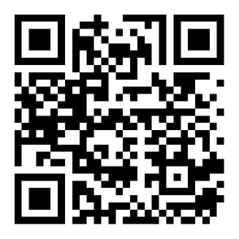

Student Signature: ________________________________ Date:___________

Parent Signature: _________________________________ Date:___________
Principal Signature: Mr. Ronald Garlington Date: 9/10/2024

